Interview Questions

1🡪 features of anypointplatform?

..Anypoint Platform is a unified, hybrid, highly productive integration platform that allows developers to create a seamless application network of applications, data, and devices.

Talk about design centre, runtime manager man, api man, exch, access management: here we can grant permission to users.. you can enable, disable, or delete users.. You can also invite new users and also manage existing users of your organization, visualizer: It provides a real-time, graphical representation of the API and Mule Application that are running and discoverable

2🡪 what is ESB?

..An Enterprise Service Bus (ESB) is fundamentally an architecture. It is a set of rules and principles for integrating numerous applications together over a bus-like infrastructure. [ESB](https://www.mulesoft.com/platform/soa/mule-esb-open-source-esb) products enable users to build this type of architecture, but vary in the way that they do it and the capabilities that they offer. The core concept of the [ESB architecture](https://www.mulesoft.com/resources/esb/why-use-esb) is that you integrate different applications by putting a communication bus between them and then enable each application to talk to the bus. This decouples systems from each other, allowing them to communicate without dependency on or knowledge of other systems on the bus. The concept of ESB was born out of the need to move away from point-to-point integration, which becomes brittle and hard to manage over time. Point-to-point integration results in custom integration code being spread among applications with no central way to monitor or troubleshoot. This is often referred to as "spaghetti code" and does not scale because it creates tight dependencies between applications.

..SOA is an architectural approach where you expose and encapsulate 'services' in a coarse-grained manner. It does not prescribe any technical mechanism or implementation. SOA is more related to boundary / integration interaction between systems. So if system A exposes services using a SOA I can interact with those services from system B.

.. An ESB on the other hand is a technical implementation that aids in delivering a SOA.

Other def: SOA is service oriented architecture. In SOA services are decoupled and can interact with each other irrespective of the service type. Meaning a particular service can be platform or protocol specific but SOA enables such services to interact and exchange data. This data is essentially exchanged via ESB (Enterprise service bus) which forms the backbone of any SOA architecture.

Ref: <https://www.mulesoft.com/resources/esb/what-esb>

<https://stackoverflow.com/questions/14872020/difference-between-soa-and-esb#:~:text=5%20Answers&text=SOA%20is%20an%20architectural%20approach,in%20a%20coarse%2Dgrained%20manner.&text=So%20if%20system%20A%20exposes,aids%20in%20delivering%20a%20SOA>.

3🡪 what is saas and etl?

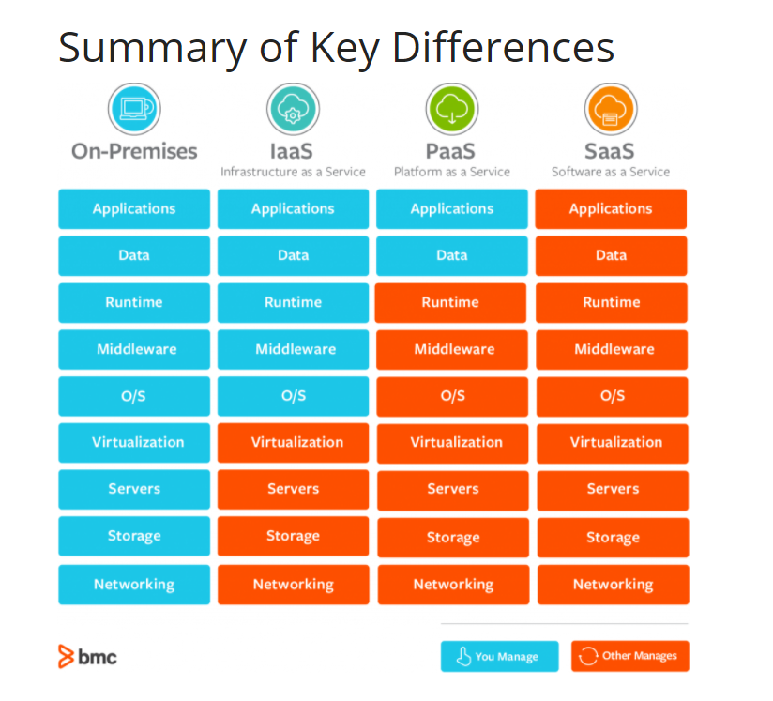

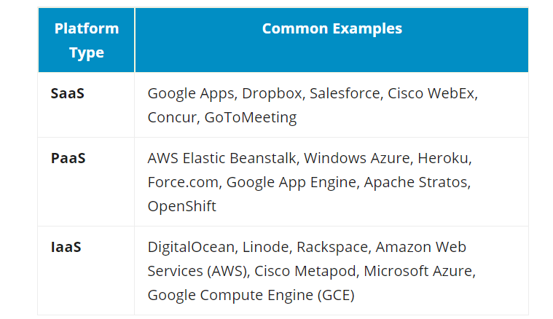

.. Software as a Service, also know as SaaS, is a [cloud-based service](https://www.techradar.com/in/best/best-cloud-computing-services) where instead of downloading software your desktop PC or business network to run and update, you instead access an application via an internet browser. The software application could be anything from [office software](https://www.techradar.com/in/best/free-office-software) to [unified communications](https://www.techradar.com/in/best/best-ucaas) among a wide range of other [business apps](https://www.techradar.com/in/best/best-apps-for-small-business) that are available.

Ref: <https://www.bmc.com/blogs/saas-vs-paas-vs-iaas-whats-the-difference-and-how-to-choose/>

..ETL:

.. **ETL** is a process that extracts the data from different source systems, then transforms the data (like applying calculations, concatenations, etc.) and finally loads the data into the Data Warehouse system. Full form of ETL is Extract, Transform and Load.

Ref: <https://www.guru99.com/etl-extract-load-process.html>

4🡪 what is microservices?

.. **Microservices** is an architectural style that structures an application as a collection of small autonomous services, modeled around a **business domain**

**..** each service is **self-contained** and implements a **single business capability.**

**Ref:** [**https://www.edureka.co/blog/what-is-microservices/**](https://www.edureka.co/blog/what-is-microservices/)

**6-> what is anypoint platform?**

**..** Anypoint Platform is a unified, hybrid, highly productive integration platform that allows developers to create a seamless application network of applications, data, and devices

..ref: <https://dzone.com/articles/overview-of-anypoint-platform>

7🡪What is anypoint design centre? Why we use? Example?

.. 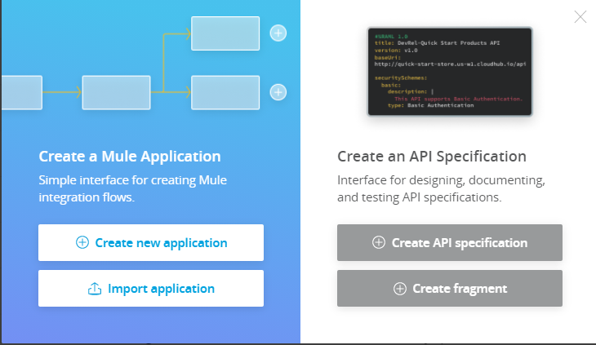

**..** A Design center is the development environment for a Mule application as well as for our API specification. In Design Center, we can create API's with the help of **RAML (RESTful API Modeling Language)**, a YAML based language, and simple Mule Applications in the flow designer component.

8🡪 What is anypoint management centre? Why we use? Example?

.. 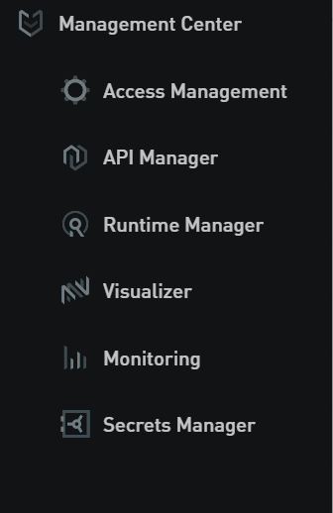

9🡪 What is anypoint exchange? Why we use? Example?

…--It is a repository/hub that helps us to share, download and incorporate assets into our Integration or Application.

--It helps us:

Create API developer portals

View and test our APIs

Simulate data to API, also called as Mocking Service

Create asset

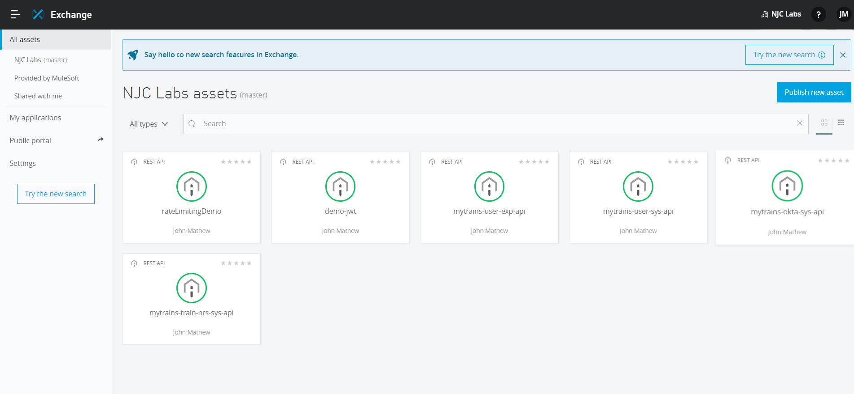

..Exchg has got pvt and public assets.

..pvt are the ones which are available to us privately for the organisation whereas public is the one that is publicly provided my mulesoft

10🡪